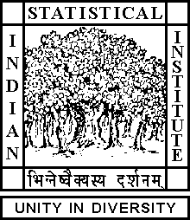

Theoretical Statistics and Mathematics Unit

Seminar

Date: June 21, 2019 Time: 04:15 P.M.

Venue: L-2, Stat-Math Unit (4th Floor, A.N. Kolmogorov Bhavan)

Aritra Bhowmick
ISI, Kolkata

Bracket Generating Distributions and Horizontal Curves

Abstract

We will discuss what are bracket generating distributions and how they occur in various aspects of mathematics. We will briefly talk about some of the known results about horizontal curves in such distributions. Lastly we'll discuss a conjecture by M. Gromov about certain corank 2 distributions. This is an ongoing work with Prof. M. Datta.

ALL ARE CORDIALLY INVITED

