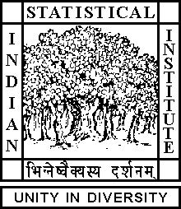

Theoretical Statistics and Mathematics Unit

Seminar

Date: September 28, 2018 Time: 04:15 P.M.

Venue: L-infinity, Stat-Math Unit (5th Floor, A.N. Kolmogorov Bhavan)

Utsav Choudhury
ISI Kolkata

Basic Algebraic Geometry of curves and surfaces

Abstract

In this lecture we will continue with projective varieties and regular functions.

ALL ARE CORDIALLY INVITED

