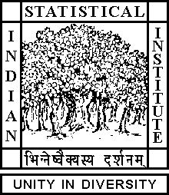

Theoretical Statistics and Mathematics Unit

Seminar

Date: August 02, 2018 Time: 03:30 P.M.

Venue: L-1, Stat-Math Unit (3rd Floor, A.N. Kolmogorov Bhavan)

Kingshook Biswas
ISI, Kolkata

Negatively curved manifolds I

Abstract:

This is part of a series whose aim is to understand the theorems of Farrell and Jones about exotic smooth structures on negatively curved manifolds constructed out of real and complex hyperbolic manifolds.

ALL ARE CORDIALLY INVITED

