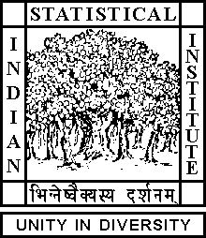

Theoretical Statistics and Mathematics Unit

Seminar

Date : February 12, 2018 Time : 04.15 p.m.

Venue : L∞, Stat-Math Unit (5th Floor, A.N. Kolmogorov Bhavan)

Mrinal Kanti Das
ISI, Kolkata

Stably free modules over smooth real affine algebras.

Abstract

Let R be a commutative Noetherian ring of dimension d.

The isomorphism classes of stably free R-modules of rank d form an abelian group. Recently, this group has been computed when R is a smooth affine domain over the field of real numbers. We give an
Exposition of those results.

All are cordially invited

