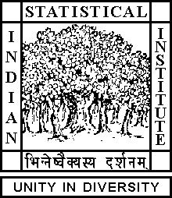

Theoretical Statistics and Mathematics Unit

Seminar

Date : August 23, 2017 Time : 04.15 p.m.

Venue : L∞, Stat-Math Unit (5th Floor, A.N. Kolmogorov Bhavan)

Souvik Dey
ISI Kolkata

Rings on which any function is a polynomial function

Abstract

It is well-known and not very difficult to prove that for any finite field K, any function from K to K is a polynomial function i.e. given any function f from K to K, there exist a polynomial P in one variable
with coefficients in K such f(a)=P(a) for all a in K. A natural question would be to explore if a similar phenomenon holds for any ring other than a finite field. We prove that there are no other kind of rings, i.e. we prove that if a ring R (not necessarily commutative, not necessarily having unity) has the property that every function from R to R can be given by a polynomial function, then R is a finite field. As an easy consequence we also deduce the nature of a ring R when functions from R^n to R, for a fixed positive integer n, has an analogous property.

All are cordially invited

