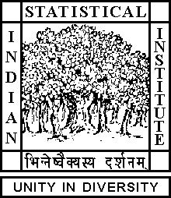

Theoretical Statistics and Mathematics Unit

The Graduate Seminar

Date: June 08, 2018 Time: 11:30 A.M.

Venue: L-infinity, Stat-Math Unit (5th Floor, A.N. Kolmogorov Bhavan)

Debanil Dasgupta
ISI Kolkata

The Dehn-Sydler Theorem

Abstract:

Gerwin and Bolyai proved that if any two polygonal regions in plane with same area are given then one can cut one of them into finitely many polygonal pieces and rearrange them to get the other one. Its 3D version is not true in general. In order to make this true for polyhedra one needs another constraint called the Dehn invariant besides volume and this is a necessary and sufficient condition which is the content of Dehn-Sydler theorem. In this talk I'll sketch the proofs of both Gerwin-Bolyai theorem and Dehn-Sydler theorem.

ALL ARE CORDIALLY INVITED

