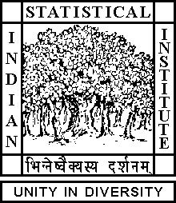

Theoretical Statistics and Mathematics Unit

Monday Colloquium

Date : July 10, 2017 Time : 04.15 p.m.

Venue : L∞, Stat-Math Unit (5th Floor, New Academic Building)

Ratan Dasgupta

ISI Kolkata

Exponential growth model for tuber crops and some characterization theorems
Abstract
We propose an exponential type growth model over time for yield of tuber crop turmeric. The experiment was continued over a period of two seasons to ensure adequate color and yield of turmeric from delayed harvest. The model is based on initial seed weight, plant height and maximum length of leaves. Some prior information on crop yield is incorporated in the model. Observations on plant height and maximum leaf length in the plants over time are available only for the first season. Yield data for different seed weights are available at the end of second season. Turmeric plants sprouted for a second time in the same pits in second season as the crop remained un-harvested at the end of first season. Yield data indicate modified exponential growth model over a bounded time period. A characterization of the discrete version of the growth curve over unequal spacing is proved.

All are cordially invited

