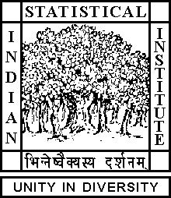

Theoretical Statistics and Mathematics Unit

Date: 23 May, 2018 Time: 02:30 P.M.

Venue: L-1, Stat-Math Unit (3th Floor, A.N. Kolmogorov Bhavan)

Souvik Dey
ISI, Kolkata

Jothilingam's generalization of Cohen and Eakin-Nagata Theorems
Abstract

Cohen's theorem in commutative ring theory states that if in a commutative ring with unity every prime ideal is finitely generated, then every ideal is finitely generated. Eakin-Nagata theorem is the fact that if R is a subring of a commutative ring with unity T and T is a Noetherian ring and finitely generated as an R-module, then R is a Noetherian ring. Over the years, there have been many generalizations of the Eakin-Nagata theorem to the module context.
One such generalization is a theorem of Jothilingam which also generalizes Cohen's theorem to the context of modules.

In this talk, we present a simpler proof of Jothilingam's theorem and in the process we also give a principle of producing prime ideals as maximal elements of
a certain set of annihilators of certain modules.

All are cordially invited

