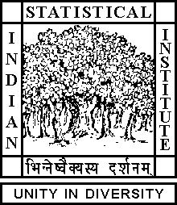

Theoretical Statistics and Mathematics Unit

Seminar

Date: March 15, 2019 Time: 04:15 P.M.

Venue: L-infinity, Stat-Math Unit (5th Floor, A.N. Kolmogorov Bhavan)

MANAMI ROY
University of Oklahoma

Paramodular forms coming from elliptic curves

Abstract

There is a lifting from a non-CM elliptic curve over rationals to a paramodular form (a Siegel modular form with respect to the paramodular group) of degree 2 and weight 3 such that the spinL-function of the paramodular form is equal to the symmetric cube L-function of the given elliptic curve. We find the level of the paramodular form in an explicit and elementary way in terms of the coefficients of the Weierstrass equation of the given elliptic curve. In order to understand this lifting and to find an explicit formula for the level, we will discuss the underlying representation theoretic mechanism.

ALL ARE CORDIALLY INVITED

