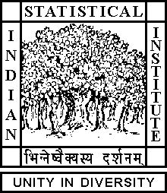

Theoretical Statistics and Mathematics Unit

Ph.D. Thesis Defense Seminar

Date: November 16, 2018 Time: 04:30 P.M.

Venue: L-infinity, Stat-Math Unit (5th Floor, A.N. Kolmogorov Bhavan

Soham Sarkar
ISI Kolkata

Some distance based statistical methods for high dimensional data

Abstract
Advancement of science, data acquisition technologies and computing facilities have brought us to the era of massive data sets. A salient feature of many of these data sets is the presence of a large number of features with much lesser sample sizes. For instance, this type of data sets is frequented in the fields of chemometrics, medical image analysis and microarray gene expression studies. Such high dimension, low sample size (HDLSS) situations have nullified the use of traditional statistical methods and have called for the emergence of new methodologies suitable for such data. In this talk, I will discuss the use of some conventional and unconventional pairwise distances to construct statistical methods which can be adequately used in HDLSS situations. In particular, I will address four problems, namely, the one-sample test, the two-sample test, the test of independence and cluster analysis.

ALL ARE CORDIALLY INVITED

