 | Pearl, Burma, Myanmar, baroque pearl, garnet pearl, gem pearl, gemstone pearl,  golden pearl, healing pearl, pearl beads, cultured pearls, freshwater pearl
  Myanmar Pearl

-Myanmar Pearls are rare and a unique souvenir to bring home from your vacation or business trip.

Pearl jewelry usually comes as freshwater pearl jewelry, cultured pearl jewelry or with pearls from oysters the pearl divers take from the Indian ocean floor, in this is case the Andaman Sea. A beautiful piece of Myanmar pearl jewelry can be just the right gift for your loved one.

Myanmar jade

- There are two kinds of Myanmar jade, jadeite is one of them, which is considered superior jade because of its clarity and nephrite.
The vast majority of visitors to have a close look for Myanmar jade emporium or jadeite fair came from Asia including Japan, Korea, Taiwan, Hong Kong, Singapore andThailand.

Myanmar rubies

Rubies and ruby jewelry are also very popular as a gift, ruby engagement rings, for ruby anniversary, ruby wedding gifts and so on. Myanmar rubies come from the area around Mogok which is a real Rubyland. When you have a look for the photos below you will see how Myanmar ruby are mined. In the area around the Chanthargyi Pagoda in Mogok a small hill provides a great panorama of the town, lake and the surrounding hills.
Myanmar has lost quite a huge piece of the ruby stone trade since there is a total lack of sophisticated mining. To mine Myanmar rubies everything is still done the traditional way as it was done since hundreds of years ago.
Little investment is made into Myanmar ruby mining since all this is tightly controlled by the government to get their share of the precious Myanmar ruby gem.

Mogok in central Myanmar is the centre of Myanmar ruby and sapphire mining. "Pigeon’s blood" Myanmar ruby, the most prized Myanmar ruby are mined in Mogok where Myanmar ruby / rubies have been found for 800 years. The area is also well known as a source of Myanmar sapphires which may be violet, green, yellow or orange in addition to the usual deep blue. Star sapphire andstar ruby from Myanmar, reflecting a six-pointed star in the light, are particularly attractive.

- Myanmar ruby mining, ruby stone, Myanmar ruby extraction,

Usually jewelry in Myanmar, ruby jewelry , sapphire jewelry and semi precious stones jewelry items don't have a very modern or art fashion styling due to the isolation of Myanmar Burma in the past, there is only very limited interaction with the outside world, but usually you get a good gem quality.

Teak is one of the main export items of Myanmar,

Handmade furniture and teak interior decoration may feature "character" or "unique detailing" but no two will look precisely alike. Handmade teak is probably the cheapest that money can buy, since southeast Asia boasts some of the cheapest labor around. Thailand teak always comeMyanmar this days.
Teak has been utilized for over two thousand years and is noted in poetry from that century. Teak logs last forever as the main structural component in buildings centuries old in Myanmar, India, Thailand and also in very old temples. This shows the amazing function of Teak to last when stressed is placed on it. Teak was a major 18th Century export for China, where flooring, cabinets, paneling and multiple other wood features were exported to Europe. Teak was frequently used for art objects, though the strong wood made this a difficult process, needing a lot of resharpening of tools. Later in the Victorian Era, this was greatly overcome and Teak art creations became more main stream.
The durability and salt water resistance made Teak especially valuable for ships, and beyond World War I, when numerous used warships were being discarded, the crews were hit by the good condition of the Teak decking and determined to save the wood. Much of it became lawn furniture, making the tradition of teak outdoor furniture. The Royal Navy was not the only one using Teak; the unique characteristics of this wood made it sought after worldwide among ship builders in the sailing age. There is an momentous whaling ship, the Charles W. Morgan, held in Mystic Seaport, Connecticut that was constructed in 1841 and had hard miles with many worldwide journeys but still looks like new.

Myanmar Silk - Silk from Myanma

-Myanmar silk is used mainly to make Cheit longyis, special garments worn by both men and women.
The silk model worn by men is called pasoe which is sarong-like attire and the silk model worn by women is called htamein which is like a skirt, both pasoe and htamien can have a distinctive wave pattern -as pictured below-.
Both pasoe and htamien have a distinctive wave pattern. Silk Cheit longyis have been in fashion and popular with royalty and commoners for many centuries. It takes great skill to weave these silk fabrics with their varied colors and intricate designs. Weaving to form traditional designs to produce a distinctive and elegant silk pattern can only be done by hand.

-Cheit longyis
were especially favored during King Mindon’s reign.Foreigners who came to pay homage fitted themselves out in the most resplendent silk cheit woven in more than thirty intricate and beautiful patterns.
The top quality silk cheit longyi is called a product of 100 shuttles because that number of small shuttles must be used in the painstaking process of weaving each piece of silk from Myanmar.
Skeins of silk thread are boiled in water and then washed clear of starch in cold water. Once the silk has reached the desired soft and delicate texture it is dyed and readied for the loom. The young women weavers must have great skill; even three years of training may not be sufficient for a weaver to become a proficient artisan. A single cheit longyi takes 180 times .
longer to weave than an ordinary longyi. The weavers working together can complete only four centimetres of fabric per day and it takes almost one month to finish a single longyi of this type.
Myanmars are justly proud to dress themselves in such prestigious and artistically crafted material to attend official functions, religious and social occasions, weddings and ceremonies. Various artists on the Myanmar stage also wear these resplendent garments.The main centre of cheit longyi weaving is in Amarapura, close to Mandalay. The most prominent companies doing this are Shwe Sintaing and Theingi Shwe Wah.

-Silk is a very special and desirable material.
A sure signs of wealth and status for many purposes like silk dresses in the latest fashion, silk window curtains for sumptuous interiors, silk scarf, silk duvet, silk lingerie, silk pajamas, silk panties, silk robe, silk sheets, silk shirt, silk dress, silk cloth and many other beautiful items.
Silk looks good, Silk comes in beautiful colors, Silk fits the body and Silk gives a pleasant feeling when it touches the skin. Different countries produce different silk. The main producers of silk are China, India and Thailand, a rather exotic type of silk comes from Myanmar Burma.
The Andaman Sea around is dotted with more than 800 untouched islands, densely forested with jungle, usually a frontline of white beaches and sometimes rocks, Myanmar Thailand travel is popular in this area.
Andaman Sea Lampi Island Andaman Sea Myanmar Indian Ocean, island world, play Robinson, exotic
island exploration, travel, islands, Andaman, Andaman sea. One of the very few “virgin” places on this planet, above and under the ocean surface. In 1990 the Myanmar government changed the mostly English names of the islands to native names.
Myanmar Agriculture
Agriculture, forestry, and fishing
Agriculture, forestry, and fishing together constitute the largest contributor to Myanmar’s economy. About half of all agricultural land in Myanmar is devoted to rice, and to increase production the government has promoted multiple cropping (sequential cultivation of two or more crops on a single piece of land in a single year), a system that is easily supported by the country’s climate. As a whole, the sector accounts for nearly one-half of the country’s gross domestic product (GDP) and employs about two-thirds of the labour force.
Myanmar is one of the few developing nations that is a net exporter of food, which accounted for 20% of its foreign exchange earnings in 2001. About 15% of the land is under cultivation. Agriculture generated roughly two-thirds of employment and 42% of the recorded GDP in 2000.Rice, by far the most important agricultural product, in 1999 covered about 5.5 million hectares (13.5 million acres) of land in the fertile Irrawaddy delta region, the lower valleys of the Sittang and Salween rivers, and along the Arakan and Tenasserim coasts. Prior to World War II (1939–45), Myanmar was the world's leading exporter of rice; annual production ranged between 13 million and 14 million tons, of which about three million tons were exported. However, the war caused extensive damage to the economy, and Myanmar did not achieve prewar levels of rice acreage and output until 1964. Rice production totaled 10.77 million tons in 2000/01. Farmers have been instructed by the government to double-crop wet season paddy and triple-crop in areas with year-round access to water. In some areas near the sea, multiple cropping brings saltwater intrusion, high flood risks, and seasonal pest problems. New high-yield varieties of rice have contributed to the increases in recent years, along with the completion of new irrigation systems and flood-control dams in the Irrawaddy delta during the early 1980s.
Other crops in 1999, grown mainly in central Myanmar and the state of Shan, included 5,429,000 tons of sugarcane, 562,000 tons of groundnuts, 303,000 tons of corn, and 210,000 tons of sesame. The use of high-yield varieties of seeds helped to more than triple the output of wheat, corn, and sunflower seeds and to double cotton production during 1976–86. Tobacco and jute are also produced, and rubber is grown on small plantations in the Tenasserim and Irrawaddy delta regions. Myanmar is the world's largest producer of opium and heroin. In 2001, opium poppy production was estimated at 865 tons.
The total amount of land under cultivation declined in the 1970s, but the amount of paddy land increased. The Mu Valley irrigation project, implemented in north-central Myanmar with UNDP aid in the 1970s, irrigated 1.7 million hectares (4.2 million acres) of farmland. With the completion of the Nawin Dam in 1982, about 40,000 hectares (99,000 acres) of new irrigated land in the Prome region, north of Yangon (Rangoon), were added to the cultivated area. With IBRD and Asian Development Bank aid, new rice storage facilities, a system of drainage canals in the heavy-rainfall paddy land of lower Myanmar, and gravity irrigation systems in dry zones were constructed.
For the wet form of agriculture rice-cultivation, the land must be lightly flooded for a good part of the season ; A good agriculture season is one in which a large proportion of the fields have water enough for an early start and in which the rainfall is steady, not leaving the surface to dry up by a long break in the rain nor deluging the soil at other times.
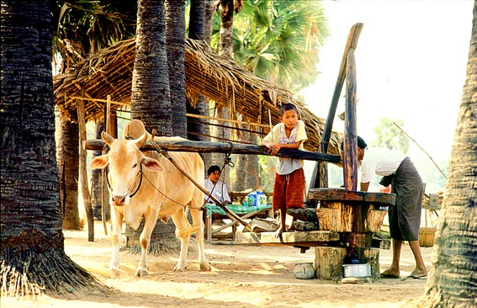
All the agriculture alluvial land of favorable elevation and quality is laid out in level rice-fields. Where the rainfall is ample-fifty inches and upwards portions of the diluvia land’s soil can be utilized in the same way by merely saving the surface-water.
In agriculture regions of lighter rainfall, in a few localities, such land is brought under rice by help of irrigation and if need be by terracing as well. The agriculture rice-fields are bordered by low turfy mounds (kazin) about a cubit high, to keep in the water.

- These regular rice-lands form large parts of Myanmar, the rest being practically irreclaimable, mainly mountain.
Other areas of the Myanmar agriculture alluvial plains (kwin) are flooded from three to ten feet deep in the rains. They are full with elephant-grass (kaing) and studded through with silk-cotton trees and a few other species. The lowest levels in the kwin form shallow lagoons which dry up in the hot season. Dry-season crops like sugar-cane (which is also grown on the wet system), maize, lentils, and vegetables for a limited market—are obtained in the kaing.
Myanmar was once the rice-mart of the world but communists ruined the country . The wet or staple agriculture cultivation of the whole Myanmar begins between June and August, as soon as the grass-sod which has formed on the rice-fields in the by-season and which has served for pasture in the interval has got thoroughly water-logged.
The Myanmar agriculture soil is then turned, about six inches deep, with a plough bearing a shoe of bronze or iron. Where elephants are available a large ton is used which does the work of four ploughs. The clods left by the plough arc broken fine, and the wet soil worked into slush by herds of buffaloes driven round and round in the fields. If there are not enough cattle, the plough-clods are worked down with harrows drawn by buffaloes or oxen.
A rotary implement is coming into use to prepare the clods for the harrow. There is very little open grass-land in the moist region. Unless the scrub which springs up is cut, the land soon relapses into jungle.
For the above Myanmar agriculture operations cattle are needful to the cultivator, though he makes little use of the manure and does not use the milk at all. The cattle are only used for

draught and very little care is bestowed on breeding.
During a great part of the Myanmar agriculture year there is no work for the buffaloes, as they are of little service for wheel-draught ; then they are left to roam at large. They frequent the streams and lagoons, where they are followed by egrets and crows, which pick the worms out of the mud as the buffaloes turn over in their wallow.
While Myanmar agriculture crops are standing, cattle have to be kept in pens at night, and herds have to watch them by day. This work is d one by children from twelve years upwards. The buffalo-pen is made near the house, if possible in a water-logged spot where the animals can wallow in the mud, which protects them from -the bites of gad-flies and mosquitoes. Where there is no wallow, smoky fires have to be made to keep the insects away.
In certain Myanmar agriculture localities of the delta cattle have to be protected with curtains. In the arid region fodder has to be grown for the cattle, but goats find pasture and are kept for their milk.
The Myanmar agriculture rice-fields first ploughed and ready are sown broad-cast for nurseries (fiyo-gin). A month later, when the rice-plants are about a foot high, they are taken up and transplanted into the prepared fields, a span apart. The roots are simply pressed down into the soft slush with the fingers or with a forked stick. The acre produces thirty to eighty bushels of grain, according to soil and season.
The Myanmar agriculture ripe corn stands three to five feet high, and so thick as to keep down tares. Unlike hill-rice which requires several heavy weedings in the season, the wet rice-fields need no care beyond that of regulating the water-supply. Where there is drainage for the water, it is allowed to stand only a few inches high on the ground.
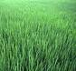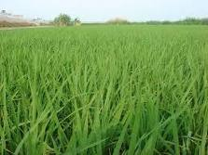
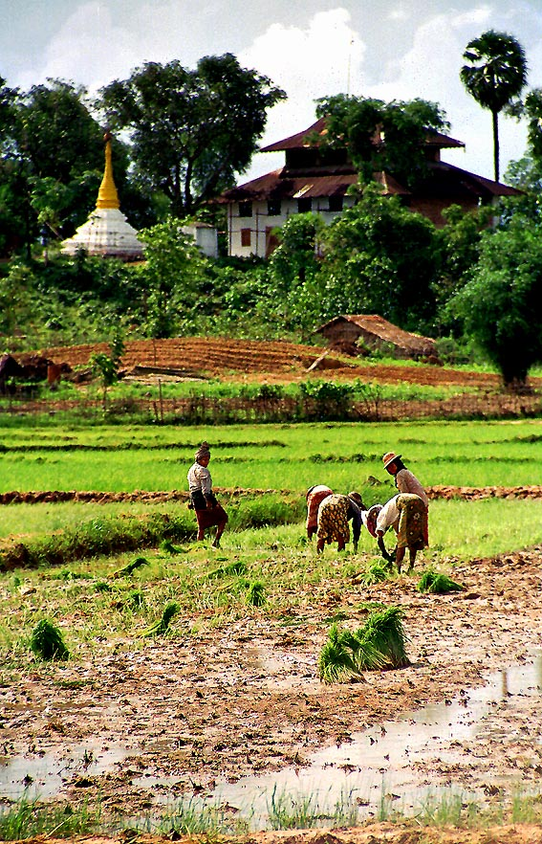  Myanmar agriculture rice field | As tee grain ripens, the soil is allowed to dry. If there is a head of water available during the rains, channels are led to the fields to keep the supply equal. If the supply is near and only at a slightly lower level than the fields, the effects of drought are counteracted by various devices such as the ka-hnwe.  Running water at too low a level to lay on to the fields is utilized by help of a bamboo water-wheel (jut), or if the water be still, the wheel is driven by ox-gear. In some parts, Myanmar agriculture rice is planted on the river banks as the floods begin to subside.  The varieties of rice, of which there are many, suited to different soils and modes of cultivation, take from three to five months to mature. The Myanmar agriculture harvest of the crops is from October to December, according to the variety and time of planting out.  When the grain turns yellow, flights of parakeets and other birds descend on the crops, from which they have to be scared till reaping-time. Bamboo clappers are worked by bast lines in a radius of a hundred yards from the watcher's hut.  Where there is an abundance of pasture for cattle, the stubble is left very high and is burned where it stands, to manure the ground.  But if straw is needed for

fodder the corn is cut close to the ground, having first been laid by pressing it down with bamboos, which makes it easier. For reaping the Myanmar agriculture villagers cooperate. But in the plains of the delta, where cultivation has extended so greatly, there is not labour enough on the spot to reap the crop. Harvest laborers come down from Myanmar proper.
The sheaves are left to dry for a day in the sun and then gathered into garbs. These are piled on a dry field into a circular heap some three feet high, and broad enough for a herd of buffaloes to tramp round upon and tread the grain off the ear, to which it is attached by a slender petiole. Another way is to pile the garbs in a high crescent-shaped heap, round the central space of which four to six head of cattle are made to travel abreast and tread the garbs which are cast down from above. The grain keeps best in the husk and is stored in bins of bamboo wattle smeared with clay.
The covering of the rice-grain is a strong adherent husk like that of barley, but without any beard. Rice in the husk is called Saba (Engl. paddy). Leaning the coarse yellow husk is a shell of bran, and beneath that a delicate white pellicle. The two outer coverings have to be removed and the inner one preserved. " Cargo rice," which forms the bulk of the mill produce, is three parts rice, simply husked, and one part paddy. The mixture bears the transport better than white rice.

Myanmar’s agriculture clean the rice according to daily need. This is done either by simple pounding or by first husking the grain in a wooden mill (kyeissiin), and then pounding it to get off the bran. The mortar is of hard wood, with a hard wood pounder as heavy as the arm can wield ; or else the pounder is mounted in a tilting-beam for foot-power. Chaff and bran are separately winnowed out with sieves and trays (sagchv) of bamboo, and in exposed places by the help of the wind also. For wholesale husking, the native mill is composed of two strong wicker-work cylinders made solid with clay, in which are embedded upright staves of hard wood As the mill wears clown, the layers of wood keep above the clay like the layers of enamel in a herbivore's tooth, maintaining a rough surface for work. In the early clays of the export trade, rice was husked for shipping in this way. The separation of the chaff is done with a machine copied from our farmyard and now manufactured.

Cleaning the rice with the hand-mill, cakes and sweets, rice is ground with water in first soaking, it is passed through the mill fluid, which is strained and used while fresh.

.

